About VendorVision

RDN’s VendorVision is a secure, web-based compliance management platform that connects companies with their vendors. VendorVision will allow companies and vendors to manage their internal operations with an eye on compliance. This tool will support internal operations and allow vendors to meet the requirements set by companies they work for.

VendorVision was developed with input from key stakeholders. Through intense requirement-gathering sessions, we have developed a product that provides all the benefits of compliance while also providing document management, task management, and a communication platform that will track and manage communications between you and your partners.

VendorVision was developed with highly skilled engineers using the latest technology and the most secure platform available. VendorVision follows the agile development process and will continue to evolve over time. As new, updated versions of VendorVision are released to our customers, we expect to capture your feedback and make additional improvements. Our company is backed by our parent organization, KAR Auction Services (KAR on NYSE), giving you the security that our company is here to stay.

Log in Instructions

Upon first logging in to VendorVision, you will be required to enter the username and password that has been provided to you. If you have not been provided with a username and password, please indicate your interest by filling out the request form and one of our customer support representatives will contact you.

The very first time you log in, you will see the following screen:
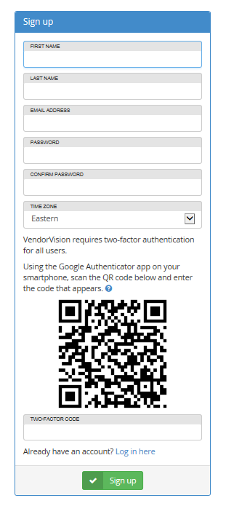
Once you enter your credentials successfully, you will be brought to the main VendorVision dashboard.

VendorVision Dashboard

After you log in, you will be taken to the VendorVision Dashboard. This Dashboard is meant to provide you with a quick snapshot of all the up-to-date tasks you need to either respond to or be aware of.

On the left you will see Open Tasks. The summary of open tasks is intended to keep you on-top of all activities that require an action on your behalf.

Below Open Tasks you will see Expiring Soon. This section outlines tasks/action items from your vendor profile that need to be addressed. For example, if some of your company data is expiring soon (training, licenses, insurance, etc.) it will be notated here. Ensuring that your company data does not expire will prevent you from losing assignments from falling out of compliance. This Expiring Soon section helps you to manage these details.

Finally, the bottom of the dashboard contains Open Trainings. This section provides details about training that must be completed by your company, the percentage your company’s employees that have completed the training and a due date.

On the right side of the dashboard, you will see a newsfeed of the latest CFPB (Consumer Finance Protection Bureau) news updates. These updates are coming directly from the CFPB and will ensure you do not miss any of the latest information you may need to ensure your company meets CFPB requirements. New updates are highlighted at the top of the newsfeed.

In the top right corner you will see a box with a number indicating the number of open tasks for your company. You can click this to go directly to the Tasks page where you will see a summary of all outstanding tasks discussed in more detail later in this document.

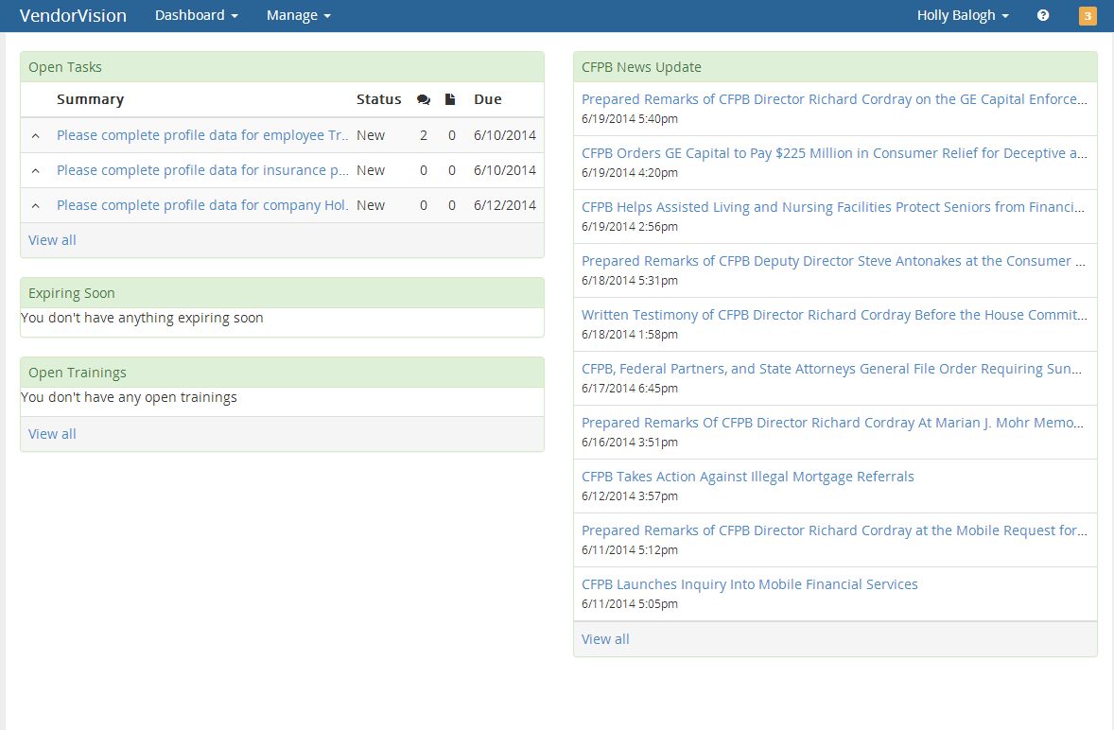

From the VendorVision dashboard, you can directly navigate to all other areas of the application. Most importantly, you can navigate to the “Manage” areas of your company to add, review, update, and manage everything related to your business.

VendorVision First Steps
As a vendor, upon login, you will be responsible for developing your company profile.
All information about your company will be logged, managed, reviewed and maintained here in VendorVision. Major areas that need to be filled out include:
- Company
- Employees
- Insurance Policies
- Insurance Carriers and Agents
- Locations
- Training
- Users
- Vehicles
- Coverage Area

As you can see from the attached screenshot, it is very easy to navigate to each of these areas to maintain your company data. See Attachment A for a comprehensive list of materials required to be documented and maintained in VendorVision.

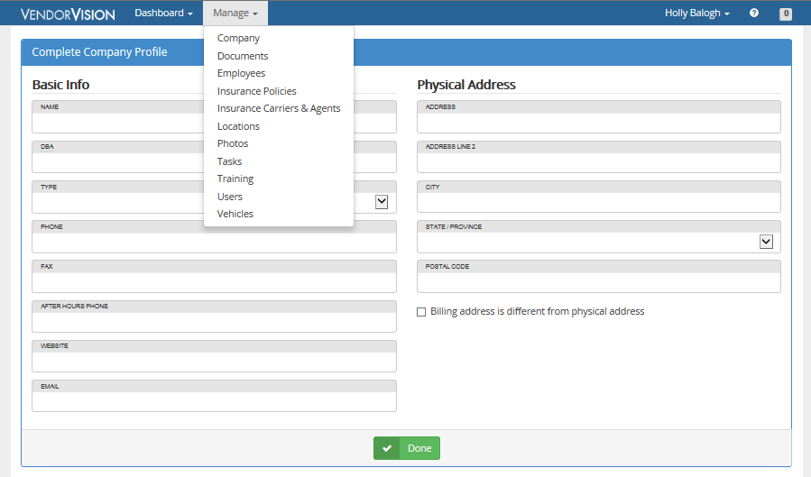

Responding to compliance remediation requests – Task Management

Tasks are the intelligence behind VendorVision. Anytime you need to complete an action item in order to remain in compliance for a company you do work for, a task will display. For example in the screenshot below, profile data was not completed. The tasks displayed on screen require a response and action in order to stay in compliance. The tasks are only created if you do not complete the action within 24 hours. This is to give you enough time to complete the documentation and not burden you with unnecessary task notifications.

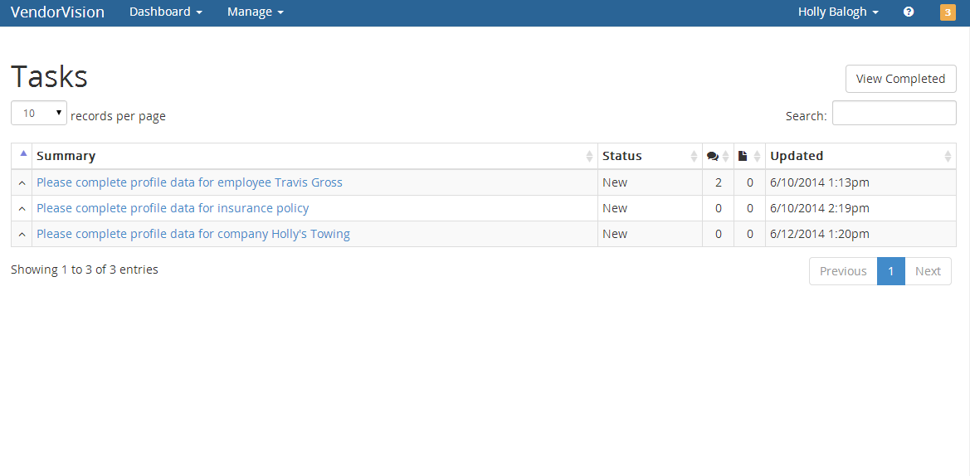

When you click on a task, you will see a summary of the task and its due date, priority and status, along with a history and area to make comments. This information is maintained for historical and audit purposes.

You should use the green buttons to change the status as you work on the task.
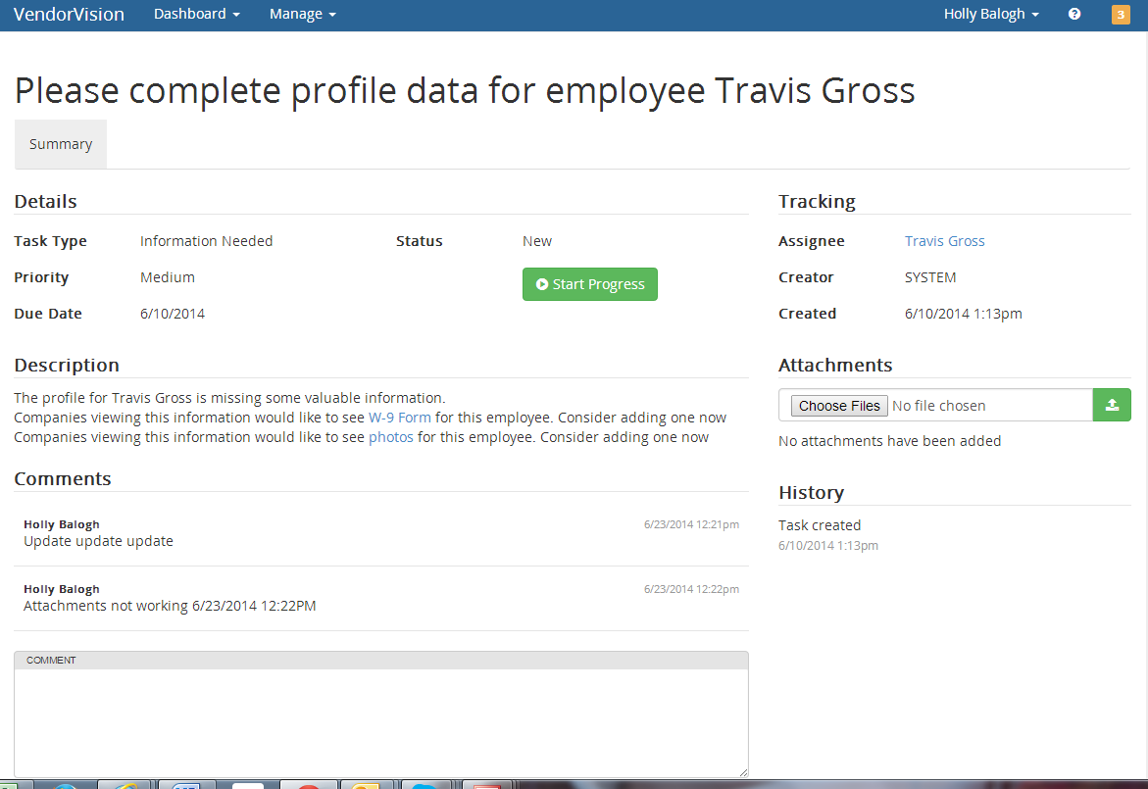

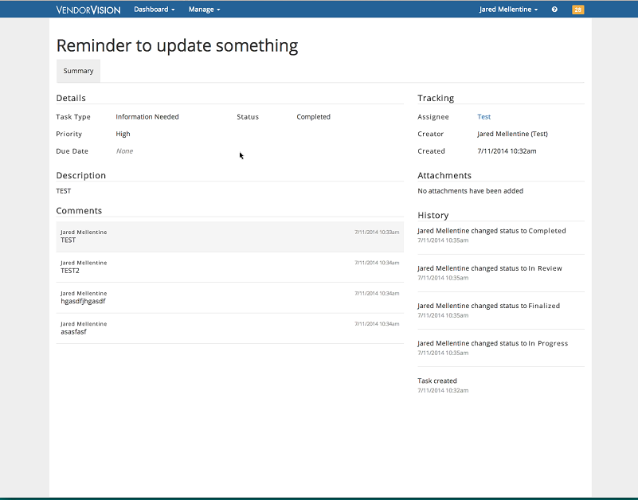

Make updates to your company profile and manage user accounts

Anytime you need to make an update to your company profile, you can navigate to the key areas in the tool using the Manage menu. After saving your changes your profile will be updated and any tasks that needed remediation resolved.

If you wish to add users, those employees in your company who will have access to VendorVision, select Users from the Manage drop down list box. From here you can add a user, delete a user, reset a password, or reset the two-factor authentication code. Users must be attached to existing employees you have setup within the tool. You will want to manage your users closely since they will have access to very sensitive company data.

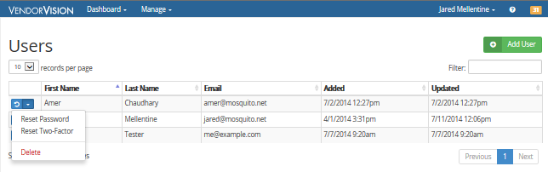

Uploading certificates/licenses/documentation
Uploading information is easy to do via the main navigation menu. Go to the Documents tab, or Photos tab, select the type of document or photo you want to upload, browse to the file on your computer and press the upload button. This easy-to-use document management tool allows you to save key company data and information in a secure environment rather than on your own company computer.

Locations
One of the most sophisticated areas of the VendorVision application is the Locations section. Here, you will manage all locations for your company. In addition to basic data for each location, you will add security information, insurance policies, coverage area, documents and photos. Following are screenshots to help you understand how to manage locations in VendorVision.

You can add and edit locations very easily. You can also update the security information, insurance policies, coverage area, documents and photos via the drop down box on the left hand side.
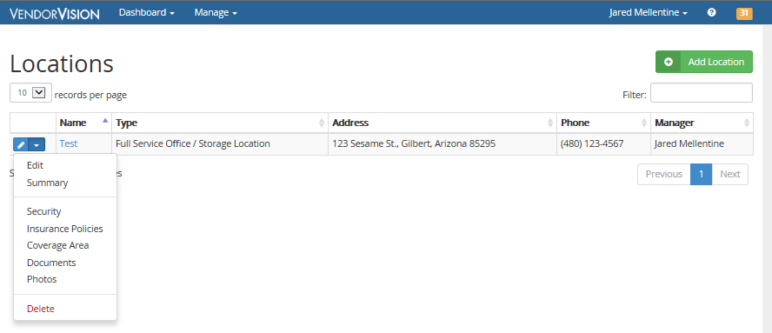

Selecting Security for the existing location will bring up all the security-related information for a particular location. This information is required to maintain compliance for each location of your business.

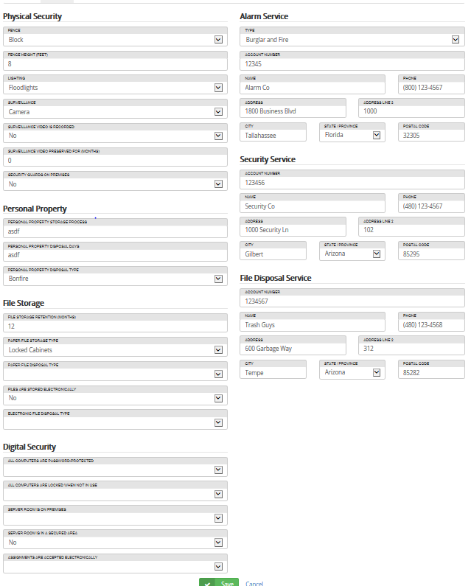

Next, you can select Insurance Policies to update information about insurance policies for that particular location.

You can access the Coverage Area section for a particular location to manage zip codes that are covered by that location. It is important to maintain accurate coverage areas so new companies can find you via this coverage area. In addition, existing companies will manage their relationship with you based on the entered zip codes.

To define a coverage area for a particular location, select the location you wish to update. Type in a Zip Code and select Add. To enter zip codes for an entire county or state, enter a county and/or state that is covered and select Add. Either option will document the zip code covered by your location.
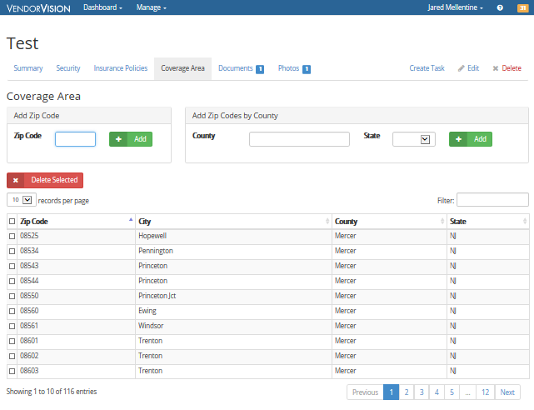
You should add documents and photos, such as your business license and repossession license, to ensure companies you work for have accurate compliance information.

Training management
Training can be provided to you from a company you do work for, or an internal training that you wish to track for your employees. Training is a key component of CFPB compliance expectations and VendorVision provides the tool to document that training was taken, including dates, and an attestation from the employee proving completion.

Training due date and number of employees in various stages of completion is available at a glance.

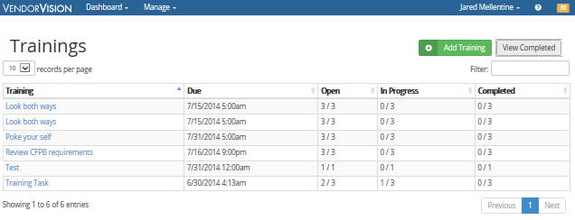

Training documentation can be added as well. You must provide a title, description, and identify which of your employees are required to complete. You can attach training material, the priority and due date.
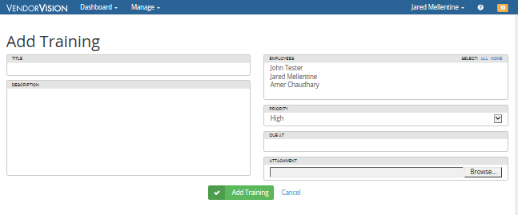

VendorVision customer support

For any support needs, you may contact our support department at 817-204-0298, option 1. They will escalate any immediate issues to our engineers for quick response to your issues.

In addition, we have developed a Wiki page that contains material which will be updated on an ongoing basis. The link to this page is: https://rdndev.atlassian.net/wiki/display/ATS/VendorVision+Support+Site

Attachment A

Materials Required in VendorVision
As a vendor, in preparation for documenting the information required in VendorVision the following information needs to be captured by your business. Having all the information available to enter into the program ahead of time will make set-up much easier the first time. Following is the outline of required documentation.

Company Materials
The company materials required include the basic information about your company’s location, contact information, hours, etc. You will be required to enter you federal TIN and DUNS number.

In addition, the company section requires you to answer basic background information.

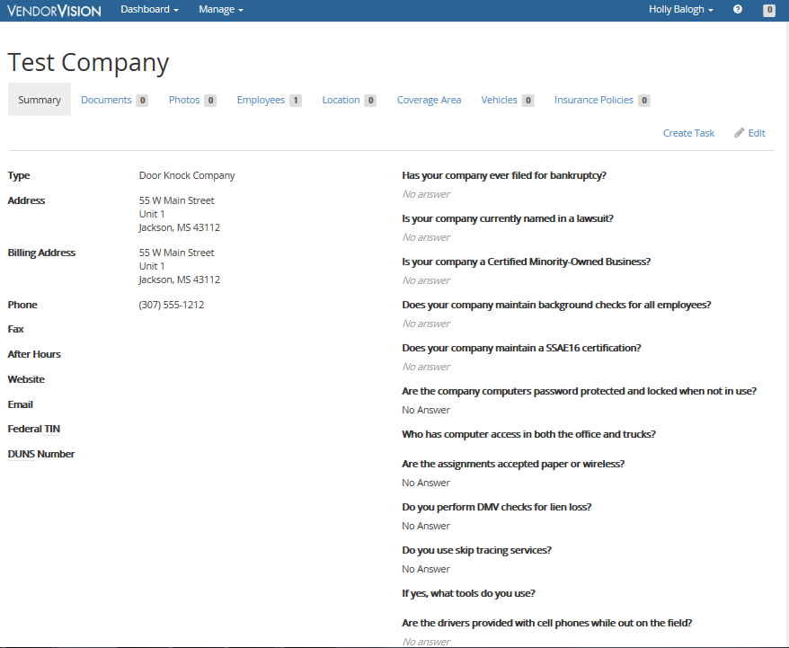

Users
The user section allows you to add login credentials for anyone who should have access to your company’s private information through VendorVision. In general, most of your employees would not have access to VendorVision due to the highly sensitive nature of the information documented and maintained within the application.

Documents

In the document section, you should upload documents that are considered critical for your company to be in compliance. Please have a PDF or other format of the following documents available to upload:

- Complaint Log
- Continued Education Training Process
- Disaster Recovery Plan
- Employee Handbook
- Information Retention Policy

Employee

The employee section is where you will enter information about people that work for you. You can manage your employees by adding, editing, or deleting them as your company evolves over time. For each employee you enter, you will be required to maintain the basic information about the person: Their contact information, driver’s license and recovery agent license numbers. You will also have the opportunity to upload information about your employee including certifications, trainings, documents (including their W-9), and a photo.

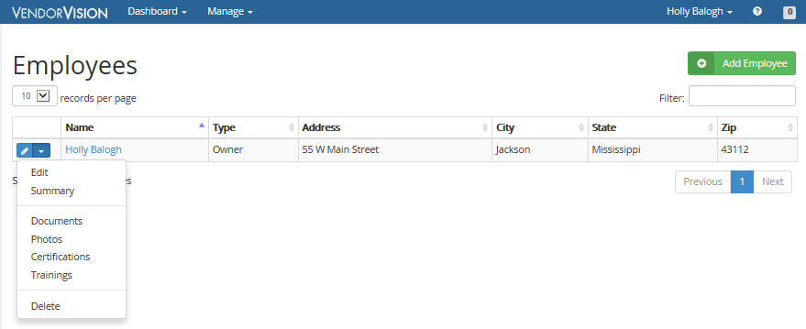

Locations

The Location section is where you will document the basic contact information and physical address information about your company locations.

In the locations area, you will need to upload your business license, repossession license, and other documents and photos related to this location.

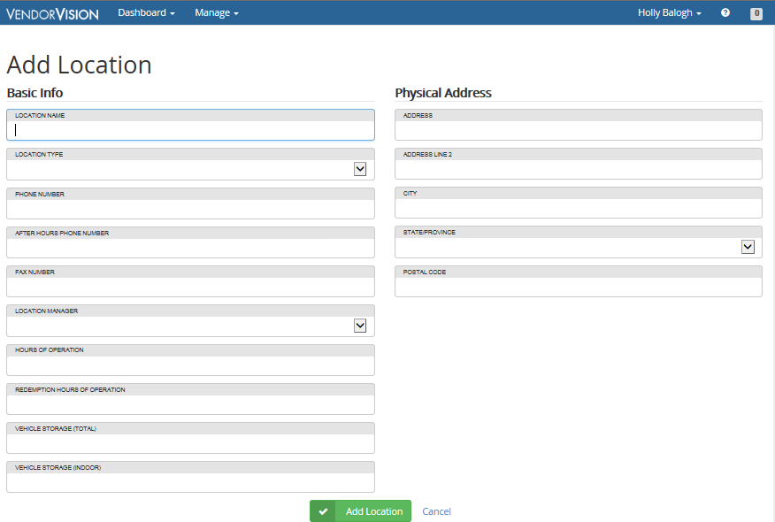

In addition, you will be required to add all security related information about each of your locations. In the next screenshot you will see the information you will be required to capture and document.

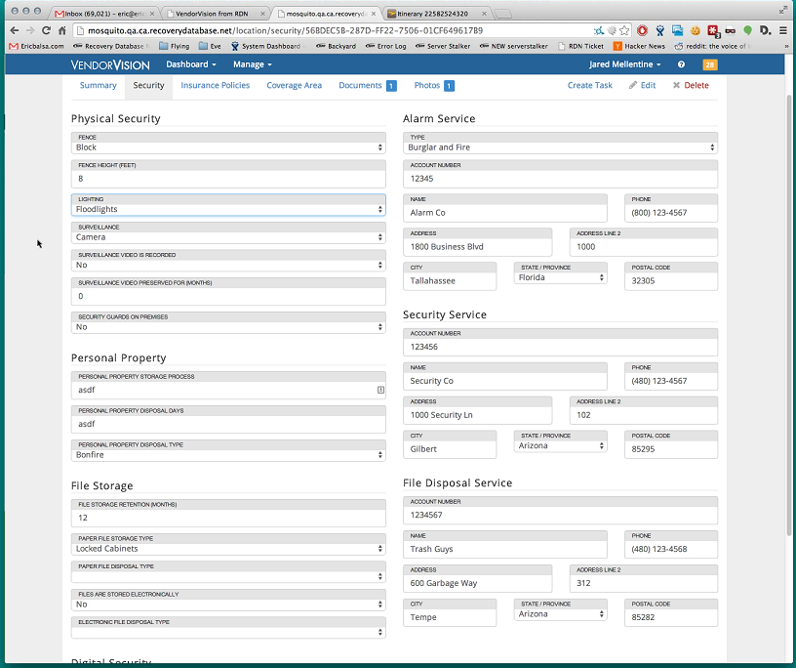

You must also define your coverage area for each location. As shown in the screenshot below, you can mark your coverage area by either entering zip codes or adding an entire county or state.

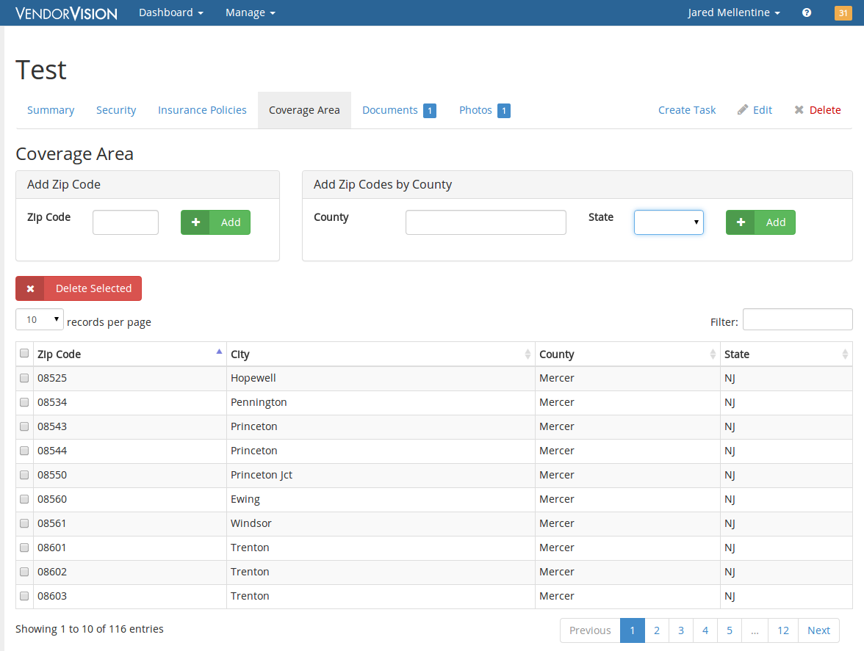

Vehicles

In the Vehicle section, you will maintain the basic information about vehicles used by your company, along with additional information. Each vehicle must be attached to a location.
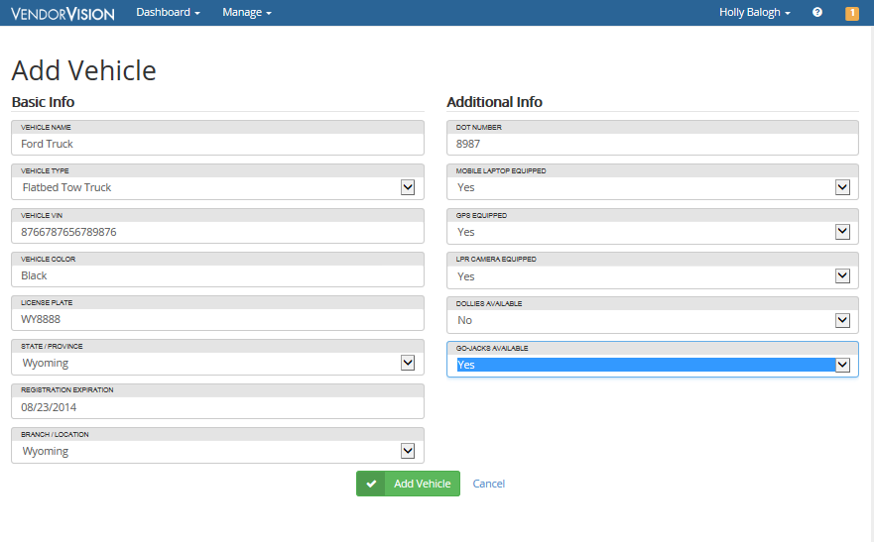
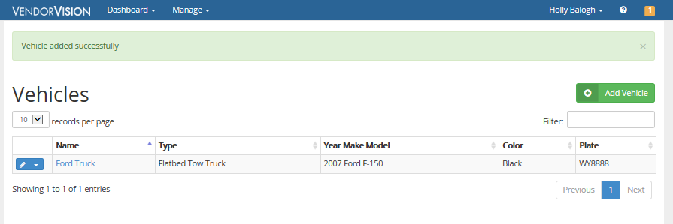

Insurance Carriers and Agents

This section requires you to enter information about your insurance carriers and your agents. Insurance carriers require basic contact information and the physical address information for each carrier you use.

Each insurance agent requires basic contact information about the agent you use.

Insurance Policies

Insurance policies will be entered into the tool for the Company, Locations and Vehicles. You must add insurance carriers and agents before you can use them in an insurance policy. Please have copies of your policies available to upload.

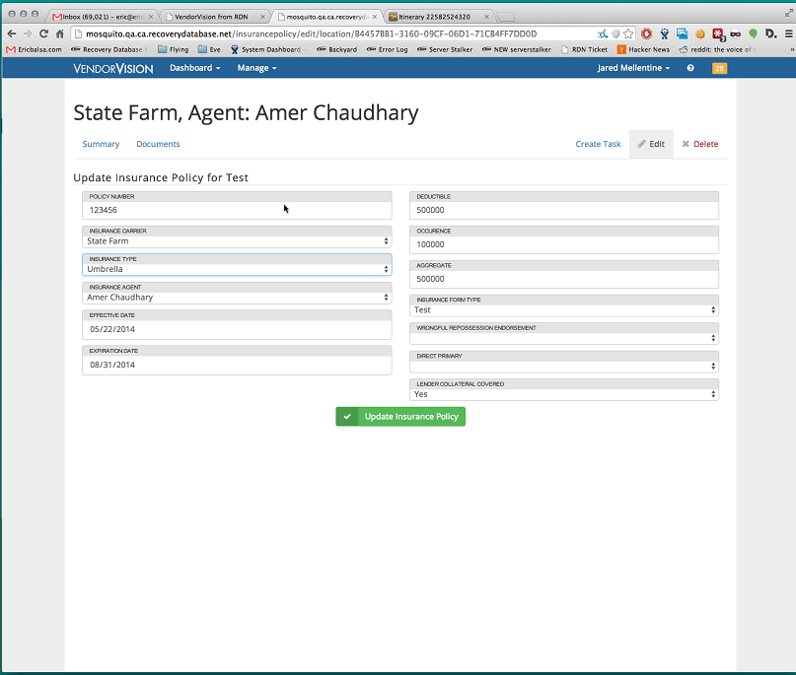

You cannot add an insurance policy from the Manage > Insurance Policies page. You can add them by using the edit drop down for that entity or using the Insurance Policy tab on the Company, Location or Vehicle page.

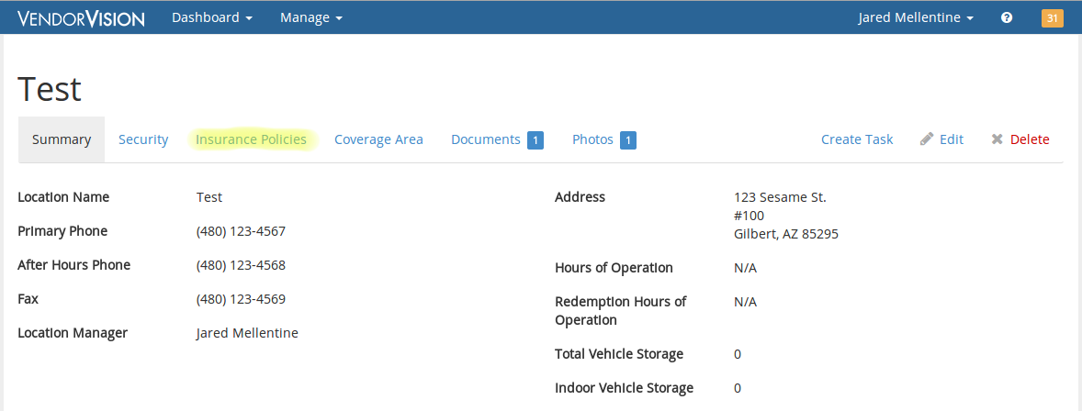
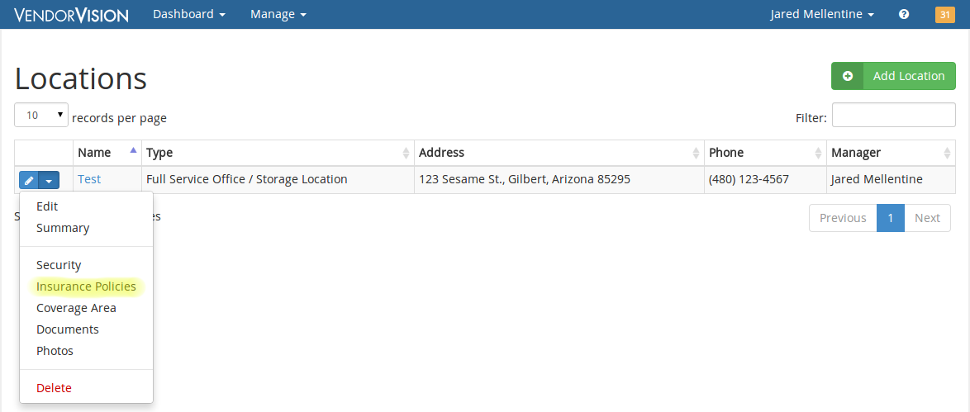

Photos

In the Photos section, you can review photos you have uploaded for your company, employees, insurance policies, locations, and vehicles.

Training

The training section offers you a chance to document training assigned to your employees, and track whether or not they have taken it. You can attach a copy of the training material and an attestation of completion of the material.
Once you create a training requirement, a corresponding task for each of the selected employees will be created. Please remember that a training requirement can also be pushed down to all of your employees from a company.

